Full Stack Development with MERN

INTRODUCTION:

Project Title: Food Ordering App using MERN

Team Members:
- Vaishnavi.B- UI/UX Designer / Backend Designer
- Srinithi.L. - Frontend Designer
- Srinithi.B. - Frontend Designer
- Prethiba.j. - Frontend Designer
- Yogashri.S .- Backend Designer

PROJECT OVERVIEW:

A Food Ordering App built with the MERN stack (MongoDB, Express, React, Node.js) allows users to browse a menu, add items to a cart, and place orders with secure payment integration. The frontend (React) offers a dynamic user experience with features like search, filters, and an order summary, while the backend (Node.js with Express) manages APIs for user authentication, food item management, and order processing. Data is stored in MongoDB, with collections for users, food items, and orders. An admin panel enables menu and order management, providing a comprehensive solution for both customers and administrators.

PURPOSE:

The purpose of a Food Ordering App using the MERN stack is to streamline the online food ordering process, allowing users to conveniently browse menus, customize orders, and make secure payments. It also enables restaurant owners to manage menus, track orders, and improve customer experience through efficient and scalable technology. Key objectives include:
- User Convenience: Enable easy browsing, ordering, and payment for food.
- Order Management: Streamline the process of tracking and fulfilling orders.
- Admin Control: Provide tools for managing menus, inventory, and customer orders.
- Scalability: Ensure the app can handle increased user demand and data growth.
- Data Security: Protect user information and payment details.

FEATURES:

- User Authentication:
  - Secure sign-up, login, and session management.
- Menu Display:
  - Categorized food items with search and filter options.
- Cart Management:
  - Add, update, and remove items with real-time updates.
- Order Processing:
  - Place orders with order tracking.
- Payment Integration:
  - Secure online payments.
- Admin Panel:
  - Manage menu, orders, and user data.
- Responsive Design:
  - Works seamlessly across devices.

ARCHITECTURE:

The architecture of a Food Ordering App using the MERN stack follows a three-tier structure:
- Frontend (React): Provides a dynamic and interactive user interface for browsing menus, managing the cart, and placing orders.
- Backend (Node.js & Express): Manages server-side logic, API endpoints, user authentication, and business rules for processing orders and payments.
- Database (MongoDB): Stores user information, food items, orders, and transaction details in a NoSQL structure.
The frontend communicates with the backend via RESTful APIs, and the backend interacts with MongoDB for persistent data storage.

FRONTEND:

The frontend of a Food Ordering App using React provides a dynamic and intuitive user interface. Users can browse the menu, search for items, and apply filters to find their desired food. The cart allows users to easily add, update, or remove items, with real-time updates for a seamless shopping experience. The order summary page lets users review their selections before checkout. The app includes secure user authentication for login and registration, while ensuring a responsive design for smooth operation on all devices. Global state management is handled using Redux or Context API to manage the cart data and user sessions. The frontend communicates with the backend via RESTful APIs to fetch real-time data, such as food items and user-specific details. Dynamic components enhance interactivity, making the app feel more engaging and user-friendly.

BACKEND:

The backend of a Food Ordering App using the MERN stack is built with Node.js and Express to handle server-side logic and API requests. It manages user authentication with JWT (JSON Web Tokens) for secure sign-up, login, and session management. The backend communicates with MongoDB to store and retrieve data, such as food items, orders, and user information. API endpoints handle CRUD operations for the menu, allowing admins to add, update, or delete food items. The order processing system tracks customer orders and their status in real-time. Secure payment gateway integration enables online transactions. The backend also manages error handling, validation, and ensures optimal performance through efficient routing. By connecting the frontend with RESTful APIs, it ensures smooth interaction and real-time updates for users. The architecture is designed for scalability, ensuring the app can handle increased traffic and data load.

DATABASE:

The database for a Food Ordering App using the MERN stack is powered by MongoDB, a NoSQL database that stores data in flexible, JSON-like documents. It includes collections for users, food items, and orders, enabling quick retrieval and manipulation of data. User information, including login credentials, profiles, and order history, is securely stored. The food items collection stores details such as names, descriptions, prices, and availability. The orders collection tracks customer orders, their status, and payment details. MongoDB’s scalability allows the app to handle large volumes of data efficiently, making it well-suited for growing user bases. Data consistency is ensured through proper validation and indexing. The database is connected to the backend via Mongoose, which provides a robust schema and model structure for interacting with the data. This flexible architecture supports quick updates and real-time data fetching, improving overall app performance.

SETUP INSTRUCTION:

Here are the setup instructions for a Food Ordering App using the MERN stack:

1. Prerequisites
- Node.js (v14 or higher)
- MongoDB (installed locally or use MongoDB Atlas)
- npm (comes with Node.js)
- Git (optional, for version control)

2. Set up the Backend (Node.js + Express)

- Create a new directory for your project:
mkdir food-ordering-app
cd food-ordering-app
- Initialize a Node.js project:
npm init -y
- Install required dependencies:
npm install express mongoose cors dotenv jsonwebtoken bcryptjs
- Create a server.js file for the backend logic.
- Set up routes for managing food items, user authentication, and order processing.
- Set up Mongoose models for User, FoodItem, and Order.
- Create a .env file for environment variables like MongoDB URI and JWT secret.
- Start the backend server:
node server.js
3. Set up the Frontend (React)
- In the same root directory, create the React app:
npx create-react-app client
cd client
- Install dependencies for the frontend:
npm install axios react-router-dom redux react-redux
- Set up the App.js file with routing and basic components for Home, Menu, Cart, and Order Summary.
- Create Redux actions and reducers to manage the global state (e.g., cart items, user authentication).
- Use Axios to make API calls to the backend for fetching food items and placing orders.
4. Connect Frontend with Backend
- In the frontend, configure Axios to make requests to the backend API for:
  - Fetching food items.
  - Creating an order.
  - User authentication.
- Use JWT tokens to manage authentication on both frontend and backend.
5. Configure MongoDB
- Set up a MongoDB Atlas account (or use a local instance).
- Create a database and collections (Users, FoodItems, Orders).
- Add the MongoDB connection string to your .env file.
6. Start the Development Environment
- Start the backend server:
node server.js
- In the client directory, start the React development server:
npm start
- Your app should now be running at http://localhost:3000 for the frontend and http://localhost:5000 for the backend.
7. Optional: Deploy
- Use platforms like Heroku for the backend and Netlify or Vercel for the frontend for deployment.
- Set up environment variables for production, such as API endpoints and MongoDB URI.

FOLDER STRUCTURE:

Client-side: React Frontend Structure

The client-side of a Food Ordering App using React is structured with components like Home, Menu, Cart, and OrderSummary. React Router handles navigation between these pages, while Redux or Context API manages global state for the cart and user data. Axios is used to fetch data from the backend API, such as food items and order details. The app is designed to be responsive, ensuring smooth functionality on both desktop and mobile devices.

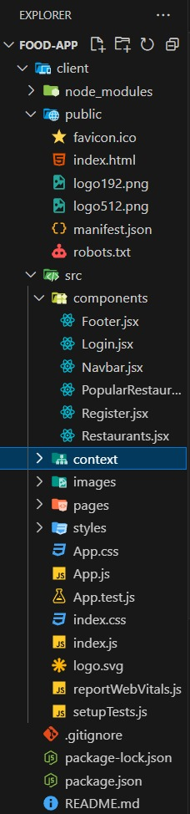

Server-side: Node.js Backend Organization

The server-side of a Food Ordering App using Node.js is organized with Express to handle routing and middleware for API requests. Key routes include user authentication, food item management, and order processing. Mongoose is used to define models and interact with the MongoDB database. The backend also includes JWT authentication for secure user login and session management, ensuring safe and efficient communication with the frontend.

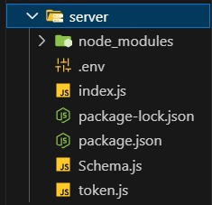

RUNNING THE APPLICATION:

To start the Food Ordering App locally with the MERN stack, follow these steps:

Backend Server:

Navigate to the backend folder (e.g., food-ordering-app):

cd food-ordering-app

Install dependencies:

npm install

Start the backend server:

node server.js

The backend should now be running on http://localhost:5000.

Frontend Server:

Navigate to the frontend folder (e.g., client):

cd client

Install dependencies:

npm install

Start the frontend development server:

The frontend should now be running on http://localhost:3000.

With both servers running, you can access the app locally.

API DOCUMENTATION:

API documentation for a Food Ordering App using the MERN stack outlines the endpoints and methods used for communication between the frontend and backend. Below is a basic structure for the API:

- User Authentication

- POST /api/auth/register: Register a new user.

  - Request Body:

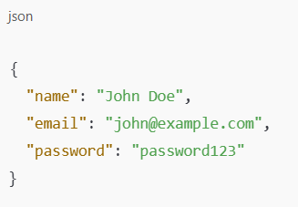

- Response: 201 Created, user data.

POST /api/auth/login: Login an existing user.

- Request Body:

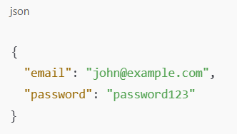

- Food Items Management

- GET /api/foods: Retrieve all food items.

  - Response:

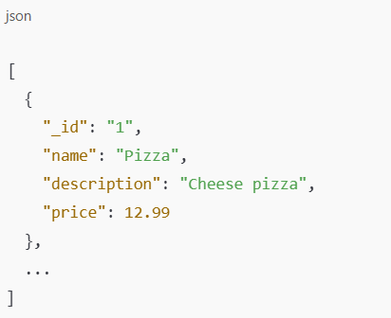

POST /api/foods: Add a new food item (Admin only).

- Request Body:

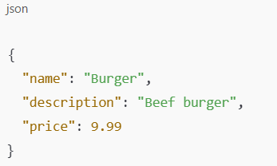

PUT /api/foods/:id: Update an existing food item (Admin only).

- Request Body:

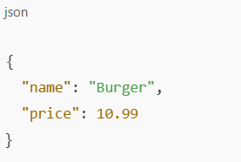

- DELETE /api/foods/:id: Delete a food item (Admin only).

- Order Management

- POST /api/orders: Place a new order.

  - Request Body:

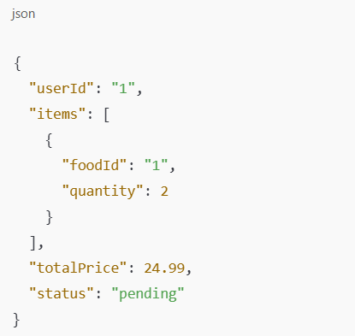

GET /api/orders/:userId: Retrieve orders by user ID.

- Response:

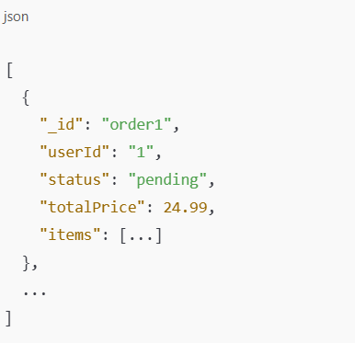

UT /api/orders/:id: Update the status of an order (Admin only).

- Request Body:

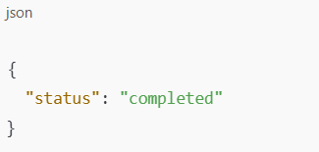

- Payment Integration

- POST /api/payment: Handle payment for orders.

  - Request Body:

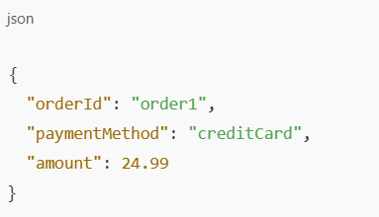

AUTHENTICATION AND AUTHORIZATION IN SKILLPLUS
In a Food Ordering App using the MERN stack, Authentication ensures secure user login via JWT (JSON Web Tokens).
Users sign in with their credentials, and a JWT is issued, stored in local storage or cookies.
Authorization restricts access to specific resources based on roles (e.g., only admins can manage food items).
Token Expiry enhances security by limiting the validity of tokens, typically for 15–30 minutes.
Refresh Tokens are issued alongside the access token to generate a new token without requiring the user to log in again, ensuring seamless session continuity.
Session Management handles user activity, storing necessary data like user roles and login status.
The Authentication Flow involves user login, token issuance, verification on each request, and automatic renewal using refresh tokens, maintaining a balance between security and user experience.

- Authentication

- In a Food Ordering App using the MERN stack, authentication ensures secure access by verifying user identities. Users register with their credentials, which are hashed and stored in the database.
- During login, credentials are verified, and a JWT (JSON Web Token) is issued upon successful authentication
- This token is sent with each subsequent request in the Authorization header, allowing the server to verify the user's identity without storing session data. This stateless approach enhances security and scalability.

2.Authorization:

- In a Food Ordering App using the MERN stack, authorization controls user access to specific resources and actions based on their roles.
- After authentication, the user's role (e.g., admin or customer) is verified through their JWT.
- Admins can access protected routes to manage food items and orders, while regular users are restricted to viewing menus and placing orders.
- This role-based access ensures that only authorized users can perform sensitive operations, enhancing security and preventing unauthorized actions.

Token Expiry and Refresh

- In a Food Ordering App using the MERN stack, token expiry and refresh mechanisms enhance security and user experience.
- Access tokens (JWTs) have a short lifespan (e.g., 15–30 minutes) to minimize the risk of misuse if compromised.
- When an access token expires, a refresh token, which has a longer validity, is used to request a new access token without requiring the user to log in again.
- Refresh tokens are stored securely (e.g., HTTP-only cookies) and ensure seamless session continuity while maintaining security.

Session Management

- In a Food Ordering App using the MERN stack, session management ensures a smooth user experience by maintaining user state across interactions.
- After authentication, a JWT is issued and stored in the client (e.g., local storage or HTTP-only cookies). This token allows the server to identify the user for subsequent requests without storing session data, making the system stateless.
- For long sessions, refresh tokens help renew access tokens without requiring reauthentication, ensuring security while keeping the user logged in.

Sumary of Authentication Flow:

- The authentication flow in a Food Ordering App using the MERN stack ensures secure user access and seamless session management.
- The process begins with user registration, where credentials are securely hashed and stored in the MongoDB database.
- During login, the backend verifies the credentials and issues a JWT (access token) along with a refresh token.
- The access token, which has a short lifespan, is used to authenticate API requests by including it in the Authorization header.
- The server verifies the token for each request to allow access to protected resources.
- When the access token expires, the refresh token is used to request a new one, avoiding the need for the user to log in again.
- Both tokens are securely stored, with the refresh token typically in an HTTP-only cookie.
- This flow provides a balance between security and usability, ensuring protected data access while maintaining a smooth user experience.
- USER INTERFACE:

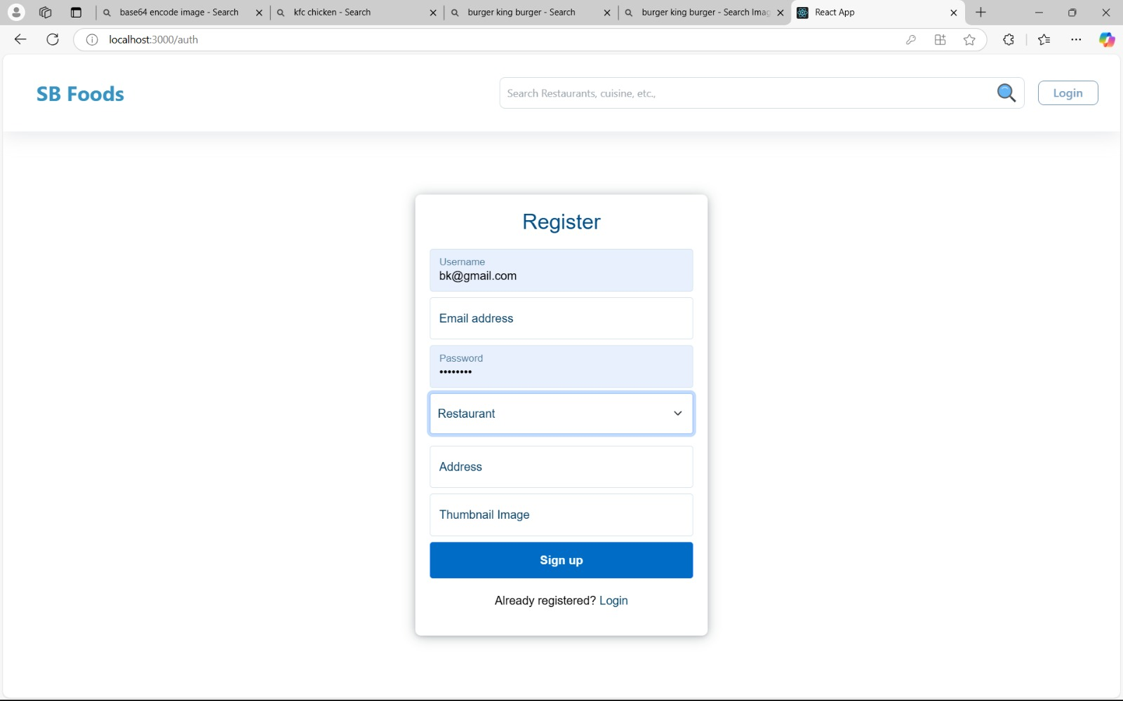

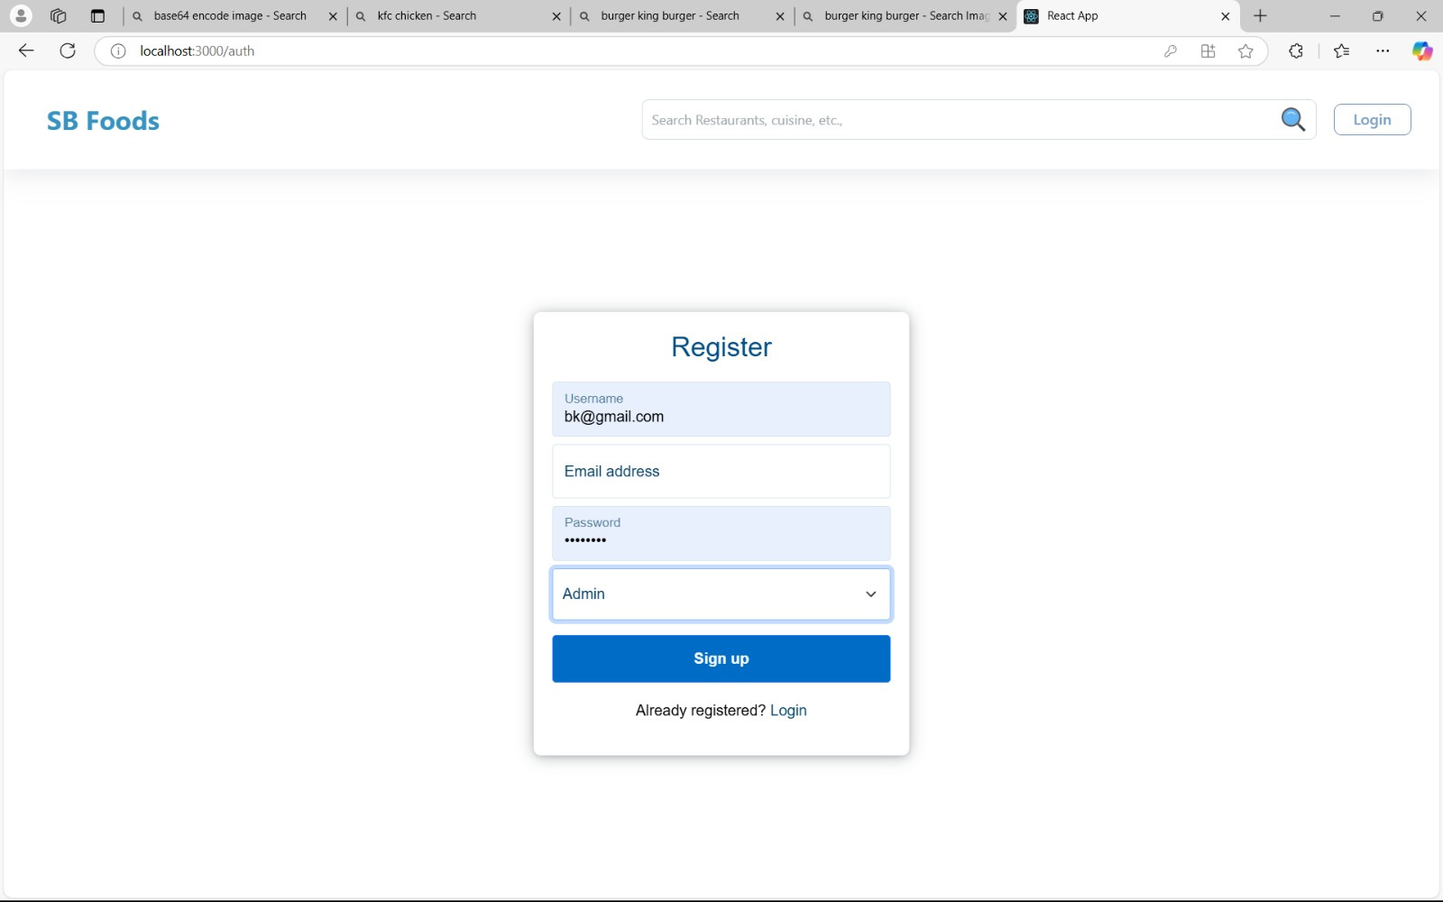

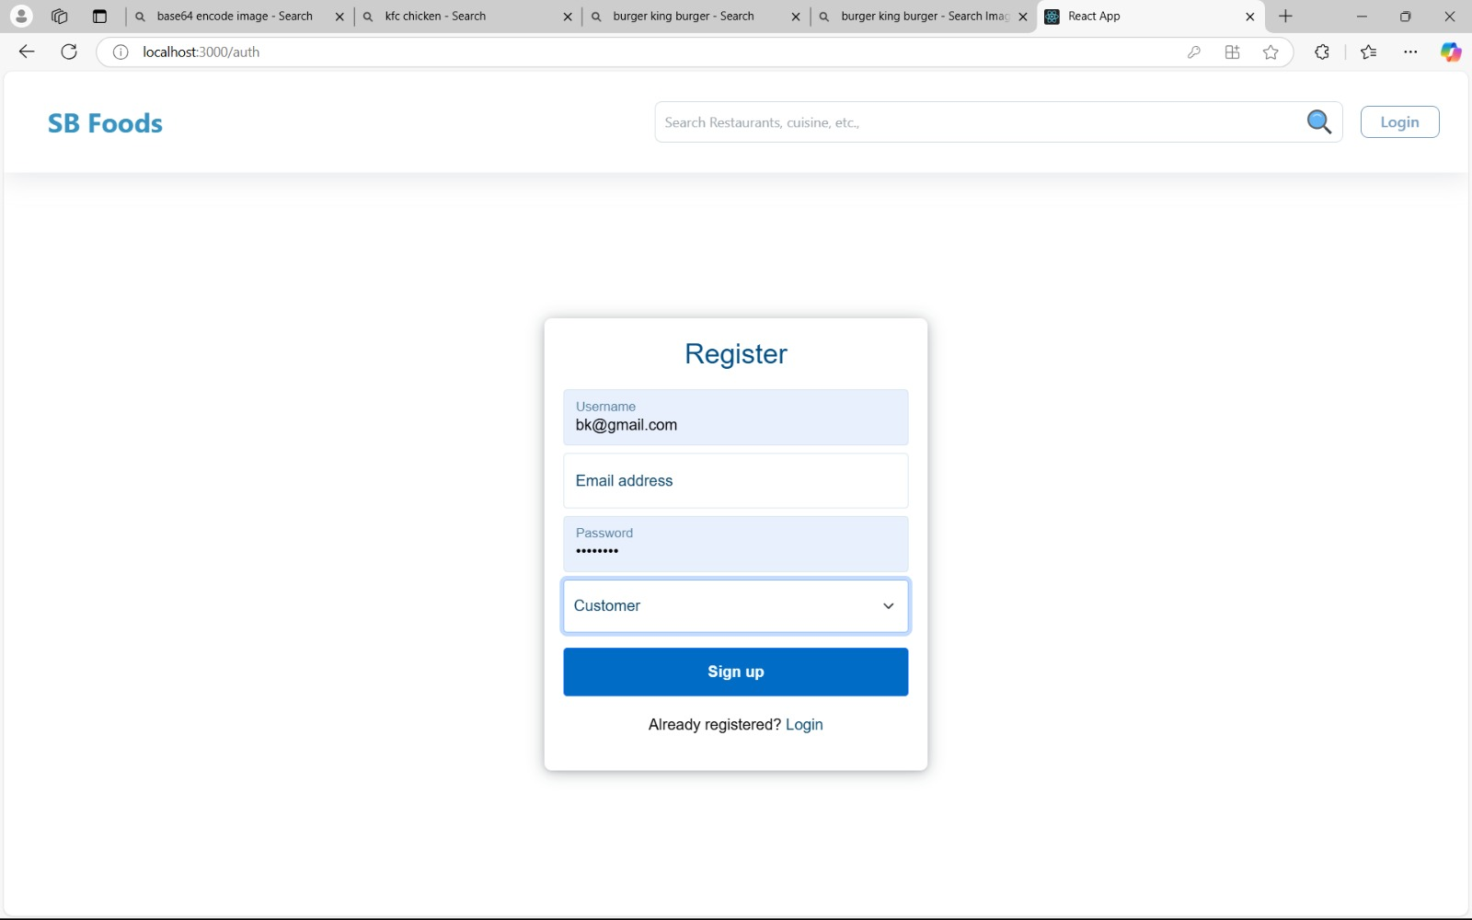

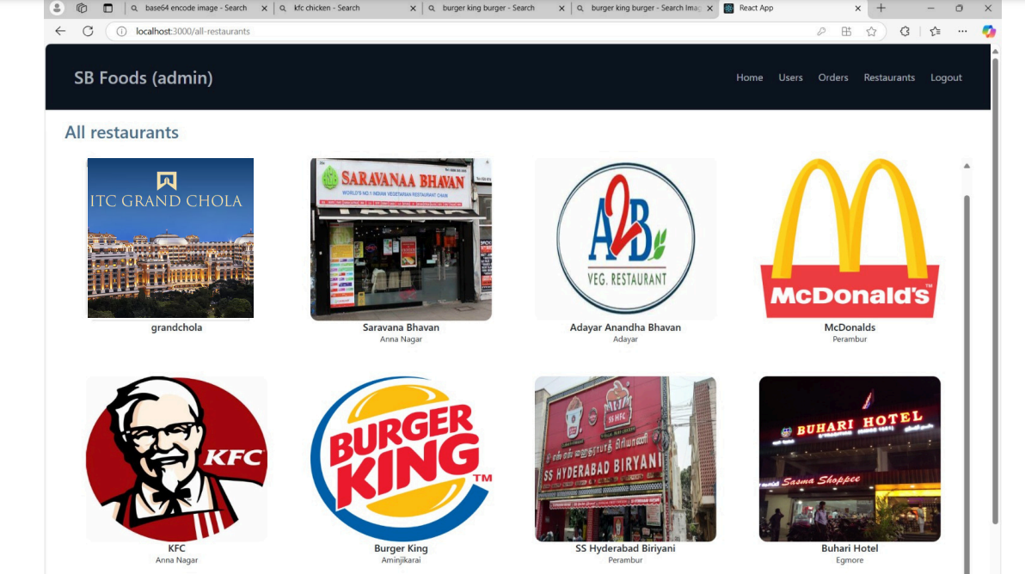

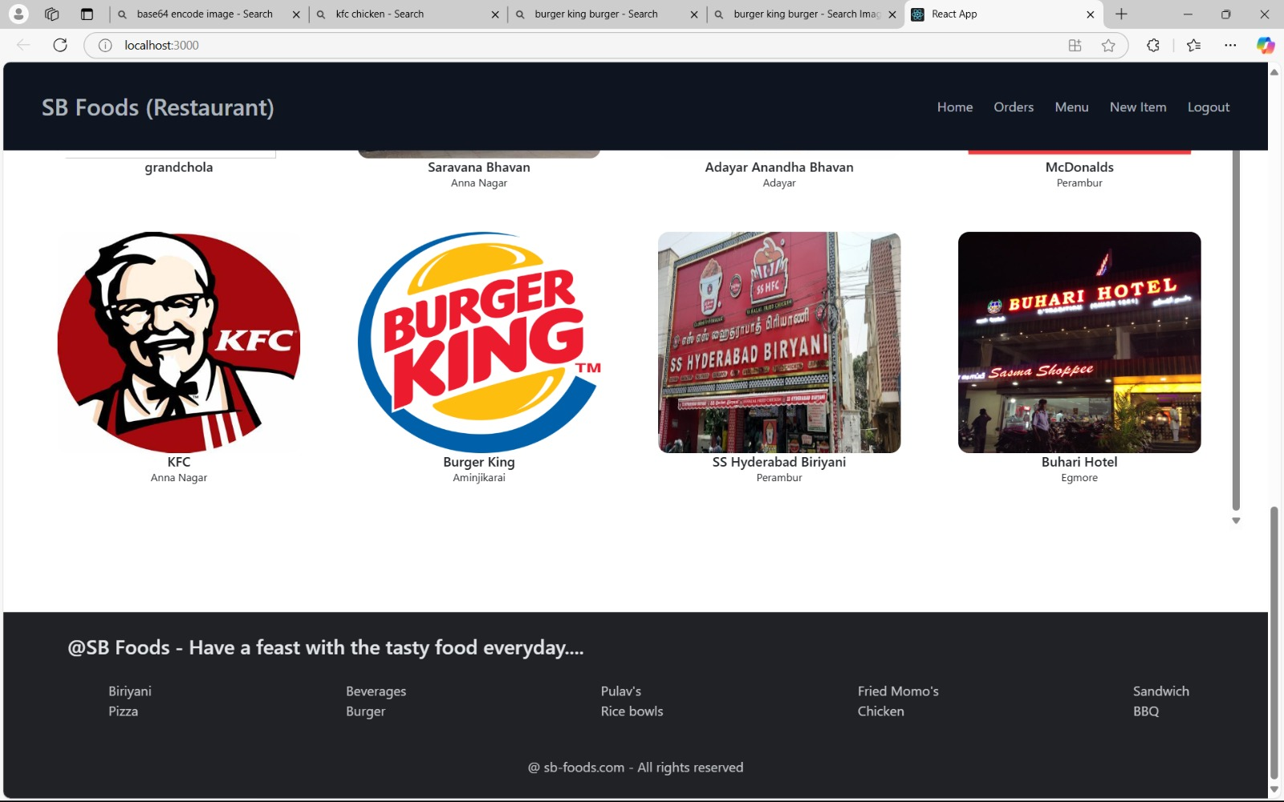

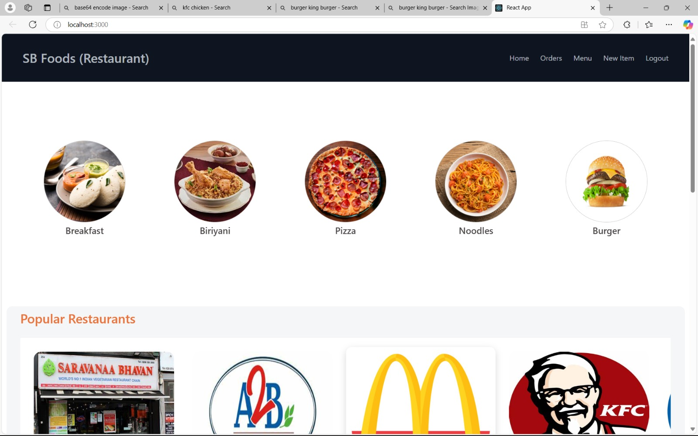

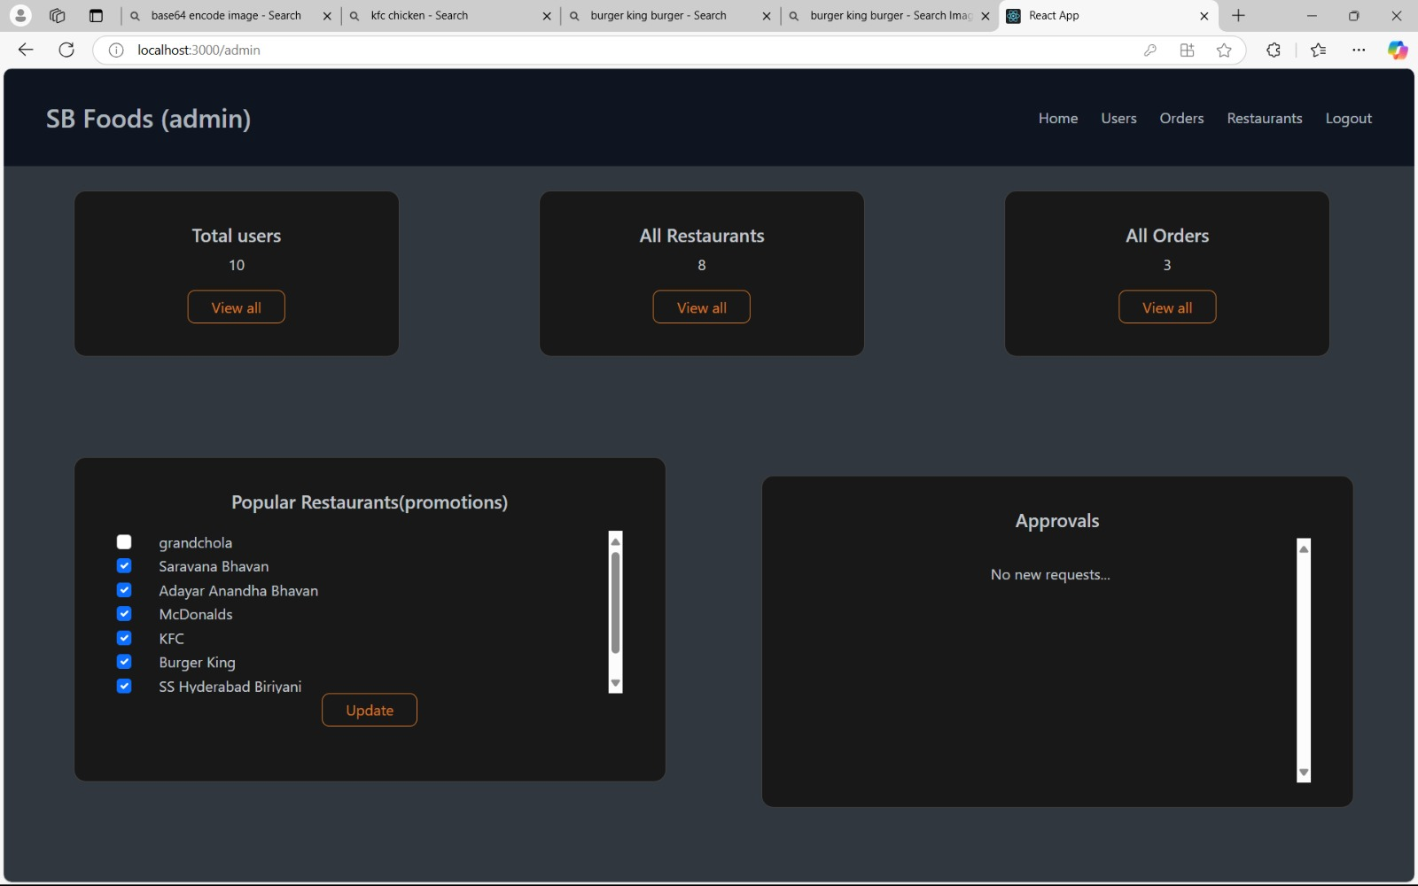

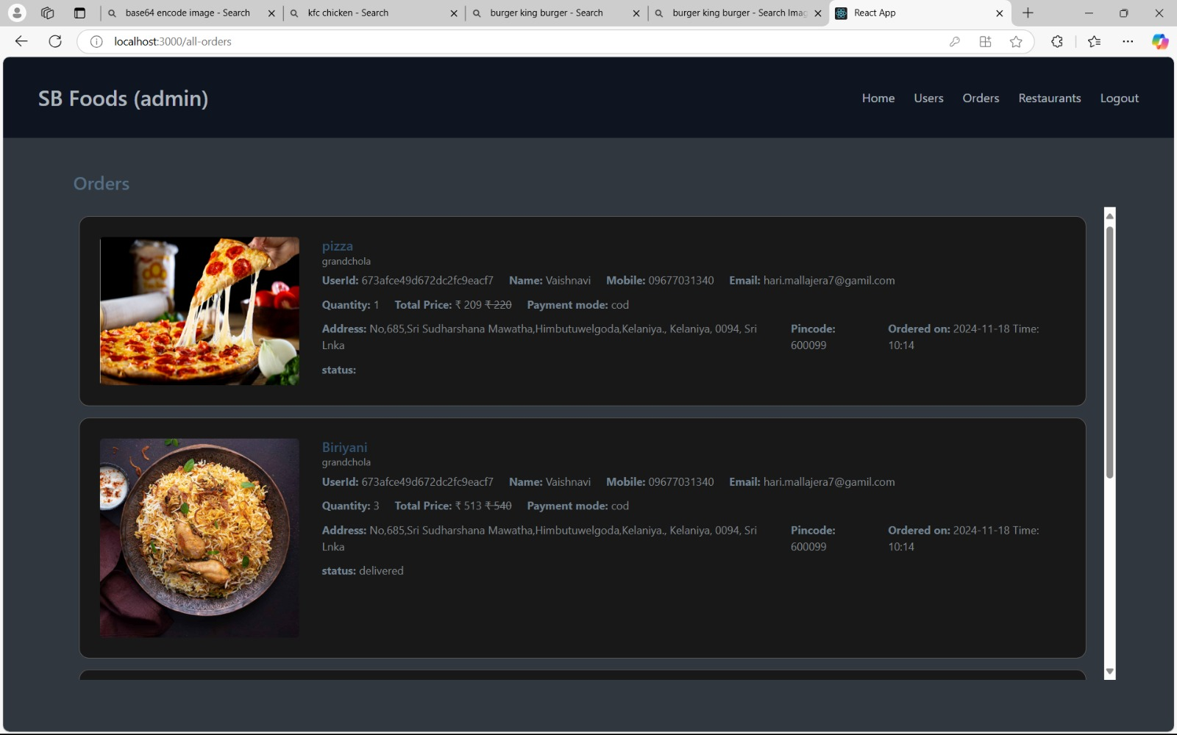

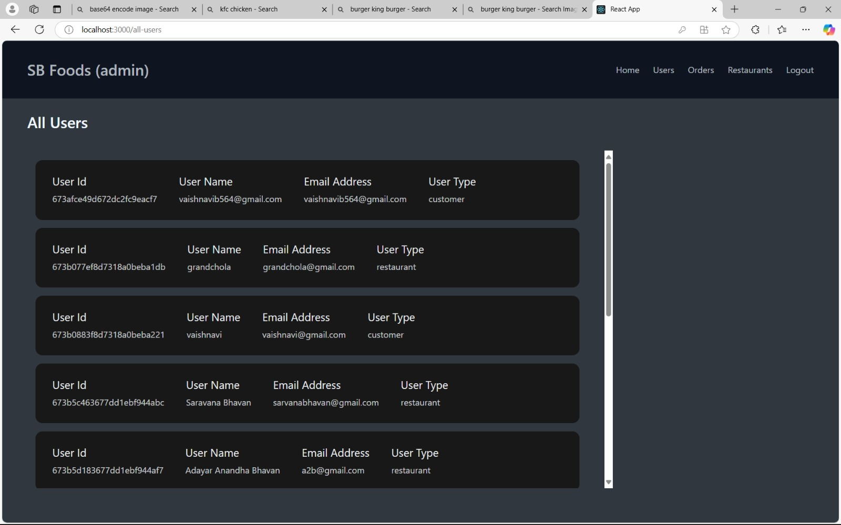

10. TESTING:

- Testing a Food Ordering App built with the MERN stack involves validating both frontend and backend functionalities.
- Unit tests ensure individual components, such as API endpoints, React components, and utility functions, work as expected.
- Integration tests verify that different modules, like the frontend and backend, interact correctly.
- End-to-end (E2E) tests simulate real user flows, from browsing the menu to placing orders, ensuring the app functions seamlessly.
- Tools like Jest, Mocha, and Cypress are commonly used for testing in MERN applications.

Frontend Testing (React)

Testing Strategy

- The testing strategy for the React frontend of a Food Ordering App involves a combination of unit, integration, and end-to-end (E2E) tests.
- Unit tests focus on individual components, ensuring they render correctly and handle user interactions using tools like Jest and React Testing Library.
- Integration tests verify the interaction between components and external services, such as API calls with Axios.
- E2E tests simulate complete user journeys, like adding items to the cart and placing orders, using tools like Cypress.
- This layered approach ensures robust and user-friendly frontend functionality.

Tools Used:

    - React Testing Library:
- Frontend testing for a Food Ordering App in React uses various tools to ensure reliability.
- Jest is the primary testing framework for running unit and integration tests.
- React Testing Library complements Jest by providing utilities to test React components' behavior and user interactions.
- For end-to-end (E2E) testing, Cypress is commonly used to simulate real user scenarios, such as navigating the app and placing orders.
- Additionally, Mock Service Worker (MSW) helps mock API calls for testing frontend behavior without depending on the backend

Continuous Integration and Deployment (CI/CD)

For a Food Ordering App using React, CI/CD pipelines automate testing and deployment to ensure a smooth development workflow. Tools like GitHub Actions or GitLab CI/CD run automated tests on every code push, including unit, integration, and end-to-end tests, ensuring code quality. Once tests pass, the app is automatically built and deployed to platforms like Netlify or Vercel for the frontend. This process ensures rapid, reliable updates and minimizes downtime.

GitHub Actions:
GitHub Actions is used in a Food Ordering App built with React to automate the CI/CD pipeline. It triggers workflows on code pushes or pull requests, running tests such as unit, integration, and end-to-end tests. GitHub Actions integrates with tools like Jest, React Testing Library, and Cypress to ensure that the frontend works as expected before deployment. After successful tests, it automates the build and deployment processes, pushing updates to platforms like Netlify or Vercel. This ensures continuous delivery with high code quality and minimal manual intervention.

DEMO VIDEO LINK:

https://drive.google.com/file/d/1jUvK2qJbpS3bCO4aa32AsvElRsd5fbxl/view?usp=drivesdk

KNOWN ISSUES

Here are some known issues in a Food Ordering App using the MERN stack:

- Performance Bottlenecks: Backend may struggle with high traffic or large numbers of concurrent users and orders.

- CORS Issues: Cross-origin resource sharing problems may occur when the frontend and backend are hosted on different servers.

- JWT Token Expiration: User sessions can be interrupted if tokens are not managed with refresh tokens or proper expiry handling.

- Responsive Design: UI may not function consistently across all device sizes, requiring additional testing and adjustments.

FUTURE ENHANCEMENT:

Here are some potential future enhancements for a Food Ordering App using the MERN stack:

Real-time Order Tracking: Implement WebSockets or Socket.io for real-time order updates, allowing users to track the status of their orders live.

Push Notifications: Integrate push notifications to alert users about order status, promotions, or new menu items.

AI-based Recommendations: Use machine learning algorithms to suggest personalized food items based on user preferences and order history.

Multi-language Support: Add language localization to make the app accessible to a wider audience in different regions.

Payment Gateway Integration: Implement more payment options like Stripe, PayPal, or Apple Pay for smoother transactions.

Admin Analytics Dashboard: Create an analytics dashboard for admins to track sales, popular items, and customer behavior.

Loyalty Programs: Introduce reward points or discount programs to increase customer retention.

Social Media Integration: Allow users to share their favorite meals or orders directly to social media platforms.

THANK YOU ALL

